Bachelor of Education (Elementary) &

Bachelor of Education (Secondary) STEM

Unit Plan Template

Unit Title: | The Rights and Responsibilities of Grade 2 | Number of Lessons | 11 | Time  (in weeks): | 7
Name: | Madison Schneider | Subject(s): | Social Studies  Writing  Drama | Grade(s): | 2/3

Rationale
This unit is important because it teaches students about their rights and responsibilities in life and in the classroom. Students learn important concepts of children’s rights, which is a vital concept as they grow and learn about how they should be treated. They learn not to take their education for granted and how to make connections to important concepts through fun and engaging ways. Human rights are a complex yet crucial topic to cover, and starting to look at it from a young age will only deepen students understanding as they grow.

Overview:
This unit breaks down key concepts of social studies, writing, and drama by teaching rights and responsibilities in engaging ways. Each unit consists of at least two of the subjects intergraded. Students will get chances to listen, discuss, create, act out, and play all while learned about their rights and responsibilities in the class and outside the class. Students get the chance to express their learning in written form and through acting it out in drama activities. Through hands-on activities/games, art, written form, stories, and visuals, students are able to make great connections to the content in meaningful ways. Students end the unit by writing a letter about what they have learned to their future selves to show their learning in a meaningful way.

CORE COMPETENCIES
Communication | Thinking | Personal & Social
Connecting and engaging with others:  Students engage in informal and structured conversations in which they listen, contribute, develop understanding and relationships, and learn to consider diverse perspectives. This facet of communication is closely linked to the building and sustaining of relationships at home, at school, in the community, and through social media. | - Critical thinking  - Creative thinking | - Positive personal and cultural identity  - Personal awareness and responsibility  Students who are personally aware and responsible have a sense of self-worth and a growing confidence in a variety of situations. They value themselves, their ideas, and their accomplishments. They are able to express their needs and seek help when needed, find purpose and motivation, act on decisions, and advocate for themselves.  - Social responsibility

BIG IDEAS
(multiple subject areas for integrated unit)
Subject Name: Social Studies | Subject Name: ELA Writing | Subject Name: Arts Education
Individuals have rights and responsibilities as global citizens | Stories and other texts connect us to ourselves, our families, and our communities | Creative expression develops our unique identity and voice

LEARNING STANDARDS
Curricular Competencies | Content
Social Studies  Use Social Studies inquiry processes and skills to ask questions; gather, interpret, and analyze ideas; and communicate findings and decisions | Rights and responsibilities of individuals regionally and globally
English Language Arts  Plan and create a variety of communication forms for different purposes and audiences  Communicate using sentences and most conventions of Canadian spelling, grammar, and punctuation | Sentence structure
Arts Education  Reflect on creative processes and make connections to other experiences | A variety of dramatic forms

Prerequisite Concepts and Skills:
-Simple concept of roles in the local community
-Introduction to responsibilities and rights
-Active listening
-How to write a sentence

Teacher Preparation Required:
Lesson # | Teacher Preparation Required (See Unit Plan Sample)
Lesson 1 | -Have chart paper ready with Venn diagram set up  -Have cards with wants and needs ready for Venn diagram  -Have Venn diagram worksheets for students (23)
Lesson 2 | -Chart paper prefilled in  -Pre read book  -Make sure students have journals
Lesson 3 | -Have backup ideas to get students moving forward if stuck
Lesson 4 | -Preview book  -Preview video  -Have worksheet printed (23)
Lesson 5 | -Write out school responsibilities on small cards and place in jar
Lesson 6 | -Make and print poster worksheet (23)  -Have chart paper ready  -Have colouring materials ready
Lesson 7 | -Bring out list of rights and responsibilities  -make cards of rights and responsibilities and place in jar  -Make and print exit ticket
Lesson 8 | -Preview book
Lesson 9 | -Preview video  -Write out child rights on chart paper
Lesson 10 | -Print exit ticket (23)
Lesson 11 | -Bring in paper and envelopes  -Write own letter example

Cross-Curricular Connections:
This is a mainly social studies unit on rights and responsibilities however it also largely incorporates English Language Arts in the writing realm as well as Arts education in the form of drama. Throughout most lessons, students learn social studies content and either connect that with writing or drama. There are lots of times where students will write either in their journals, worksheets, or exit tickets in regards to the social studies content that they are learning or they will participate in a drama activity that acts out or dramatizes the social studies content in a fun way to connect the material.

Aboriginal Connections/ First Peoples Principles of Learning:
- Learning is holistic, reflexive, reflective, experiential, and relational (focused on connectedness, on reciprocal relationships, and a sense of place).
- Learning involves generational roles and responsibilities.
- Learning involves patience and time.
There are many First Peoples principles of learning connected in this unit. My unit is largely based off of experiential learning because I also strongly believe that we learn best by doing. Therefore, I tried to incorporate hands on activities and drama-based activities for students to be able to act out and experience the content. We also look at roles and responsibilities in our classrooms, and I hope that discussions will lead to conversations about what roles look like at home and how we can understand First Peoples generational roles and responsibilities. Finally, I know I have students that can become frustrated easily when learning new things, therefore I wish to reinforce that learning takes patience and time and I want to remember this in terms of assessment in my unit as well when looking at students’ improvements throughout the content.

Universal Design for Learning (UDL)
Multiple means of representation: diagrams, charts, the volume or rate of speech, the speed and timing of videos, font on printed materials, worksheets, videos, books, games, activities, pre-teach vocabulary, connect and activate prior knowledge, model, drama activities.
Multiple means of expression: options for being active in drama games, use sentence starters, Venn diagram, scaffold, use prompts, use prompts that embed “stop & think” before acting
Multiple means of engagement: provide learners with as much autonomy as possible by providing choices in the level of challenges, design, and timing of tasks, vary activities and source information so that they can be personalized and contextualized to learners’ lives, provide tasks that allow for active participation exploration and experiential, prompt learners on when and how to ask peers or teacher for help

Differentiated Instruction (DI):
-Visual learners will be engaged throughout the unit by things like stories, books, videos, worksheets, posters
-Auditory learners will be engaged throughout the unit by videos, games, discussions, books
-Kinesthetic learners will be engaged throughout the unit by games, hands-on activities, worksheets
-Students that I know require extra help will be checked on regularly throughout work time
-Students that need to be reminded to stay on task will be reminded regularly
-Students that need assistance writing will be assisted by having the teacher write out the material on a separate paper and having the student copy it down in their own workbook

Overview of Lessons:

Lesson 1
Name &Time (Minutes Allotted): | What are wants and needs? 45 minutes
Learning Standards: Curricular Competencies | -Use Social Studies inquiry processes and skills to ask questions; gather, interpret, and analyze ideas; and communicate findings and decisions  -Communicate using sentences and most conventions of Canadian spelling, grammar, and punctuation
Learning Standards: Content | -Rights and responsibilities of individuals regionally and globally  - Sentence structure
Instructional Objectives | Students will be able to decipher between a want and a need by separating them with a Venn diagram
Assessment: | Completion of Venn diagram
Teaching Strategies: | -Positive praise  -Having material ready  -Focus on transition time
Materials: | -Chart paper  -Venn diagram worksheet  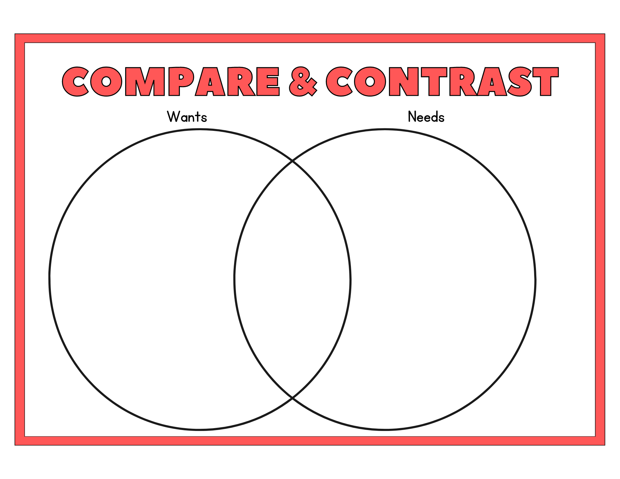
Lesson Activities:
Introduction/Hook: | -Introduce that we will be learning about wants and needs  Hook question: who likes ice cream? Do we need ice cream to survive? Do you think Ice cream is something that we need or want?
Body: | -Discussion on what wants and needs are  -Wants are things that we like; like ice cream, chocolate, video games  -Needs are things that we need to survive: water, food, shelter, love  -Look at teacher VENN diagram. Items will be placed on cards taped to the side. As a class, students decide where things should be placed (food, shelter, clothes, vacation, jelly beans, ect.).  -Students will go back to desks and fill in their own VENN diagram by copying the one at the front.
Closure: | -Students will complete verbal exit ticket on what their favourite want and need is

Lesson 2
Name &Time (Minutes Allotted): | What is a right, 45 minutes
Learning Standards: Curricular Competencies | -Use Social Studies inquiry processes and skills to ask questions; gather, interpret, and analyze ideas; and communicate findings and decisions  -Plan and create a variety of communication forms for different purposes and audiences
Learning Standards: Content | -Rights and responsibilities of individuals regionally and globally  -Sentence structure
Instructional Objectives | Students will be able to decipher what a right is and know what their rights are regarding education by learning through story and representing their learning through writing
Assessment: | -Checklist
Teaching Strategies: | -Positive praise  -Having materials ready  -Read loudly and expressively  -Keep transition time low  -Brain break
Materials: | -Chart paper  -Yasmin’s Hammer  -Journals
Lesson Activities:
Introduction/Hook: | -Start introduction on what a human right is  -A right is a special rule that is allowed and owed to people by law  -Go over some of the main rights:  1. All humans are free and equal  2.No discrimination or unfairness  3. Right to education  -For the rest of the lesson we will focus on the right to education
Body: | -In Canada it is the law that we are all allowed to go to school and learn. We are so lucky that we get to go to school everyday and learn. But in some places around the world, it is not a right to go to school. Some kids are not allowed to learn and have to work instead.  -Read “Yasmin’s Hammer” by Ann Malaspina  -Discuss the story; what happened, why Yasmin couldn’t go to school, what her dream was, how does it make you feel  -Brain break (based on the previous lesson on wants and needs. Have students all stand up and teacher call out different wants and needs. Students sit down if it is a need and stand up if they think it is a want (such as water, popcorn, clothing, sushi, basket ball, ect)
Closure: | -Students write in their journals based on the prompt of what is a right and how does the right of education effect you.

Lesson 3
Name &Time (Minutes Allotted): | New planet, New rights
Learning Standards: Curricular Competencies | Reflect on creative processes and make connections to other experiences  Use Social Studies inquiry processes and skills to ask questions; gather, interpret, and analyze ideas; and communicate findings and decisions
Learning Standards: Content | -A variety of dramatic forms  -Rights and responsibilities of individuals regionally and globally
Instructional Objectives | Students will be able to demonstrate their knowledge of rights by acting out a scenario where they get to create their own rights based on what they already know, through a drama-based activity where the teacher can quickly observe if students understand the material
Assessment: | -Participation  -Checklist
Teaching Strategies: | -Positive praise  -Give clear instructions
Materials: | -Chairs
Lesson Activities:
Introduction/Hook: | Students are being sent to a new discovered planet. No one has lived there before and there are no rules. Students must come up with a list of rights before moving to the new planet.
Body: | Students must work together to come up with a list of new rights for their new planet. Students will complete a quick brainstorm on their own and then they must talk with at least three other students to share ideas.  -Volunteer students will share a right that they think is important. Students must explain why their right is important in a press conference style manner. Students that wish to share their rights will sit in a row of chairs at the front of the class. The other students can either be reporters or spectators. Reporters will ask questions to the students at the front about their rights.  -The class will decide if those are important rights that we all want for our planet or not.
Closure: | -Final discussion: what makes a right important? Is coming up with a right hard or easy? When you come up with a right are you thinking about others?

Lesson 4
Name &Time (Minutes Allotted): | What is a responsibility, 45
Learning Standards: Curricular Competencies | Use Social Studies inquiry processes and skills to ask questions; gather, interpret, and analyze ideas; and communicate findings and decisions  Communicate using sentences and most conventions of Canadian spelling, grammar, and punctuation
Learning Standards: Content | -Rights and responsibilities of individuals regionally and globally  - Sentence structure
Instructional Objectives | Students will be able to demonstrate what a responsibility is through story and by coming up with their own responsibility statements
Assessment: | Checklist
Teaching Strategies: | -Have materials ready  -Keep transition time low  -Brain break
Materials: | -Do I have to by Nancy Loewen  -https://www.youtube.com/watch?v=7ew6herS7Gg  -Worksheet  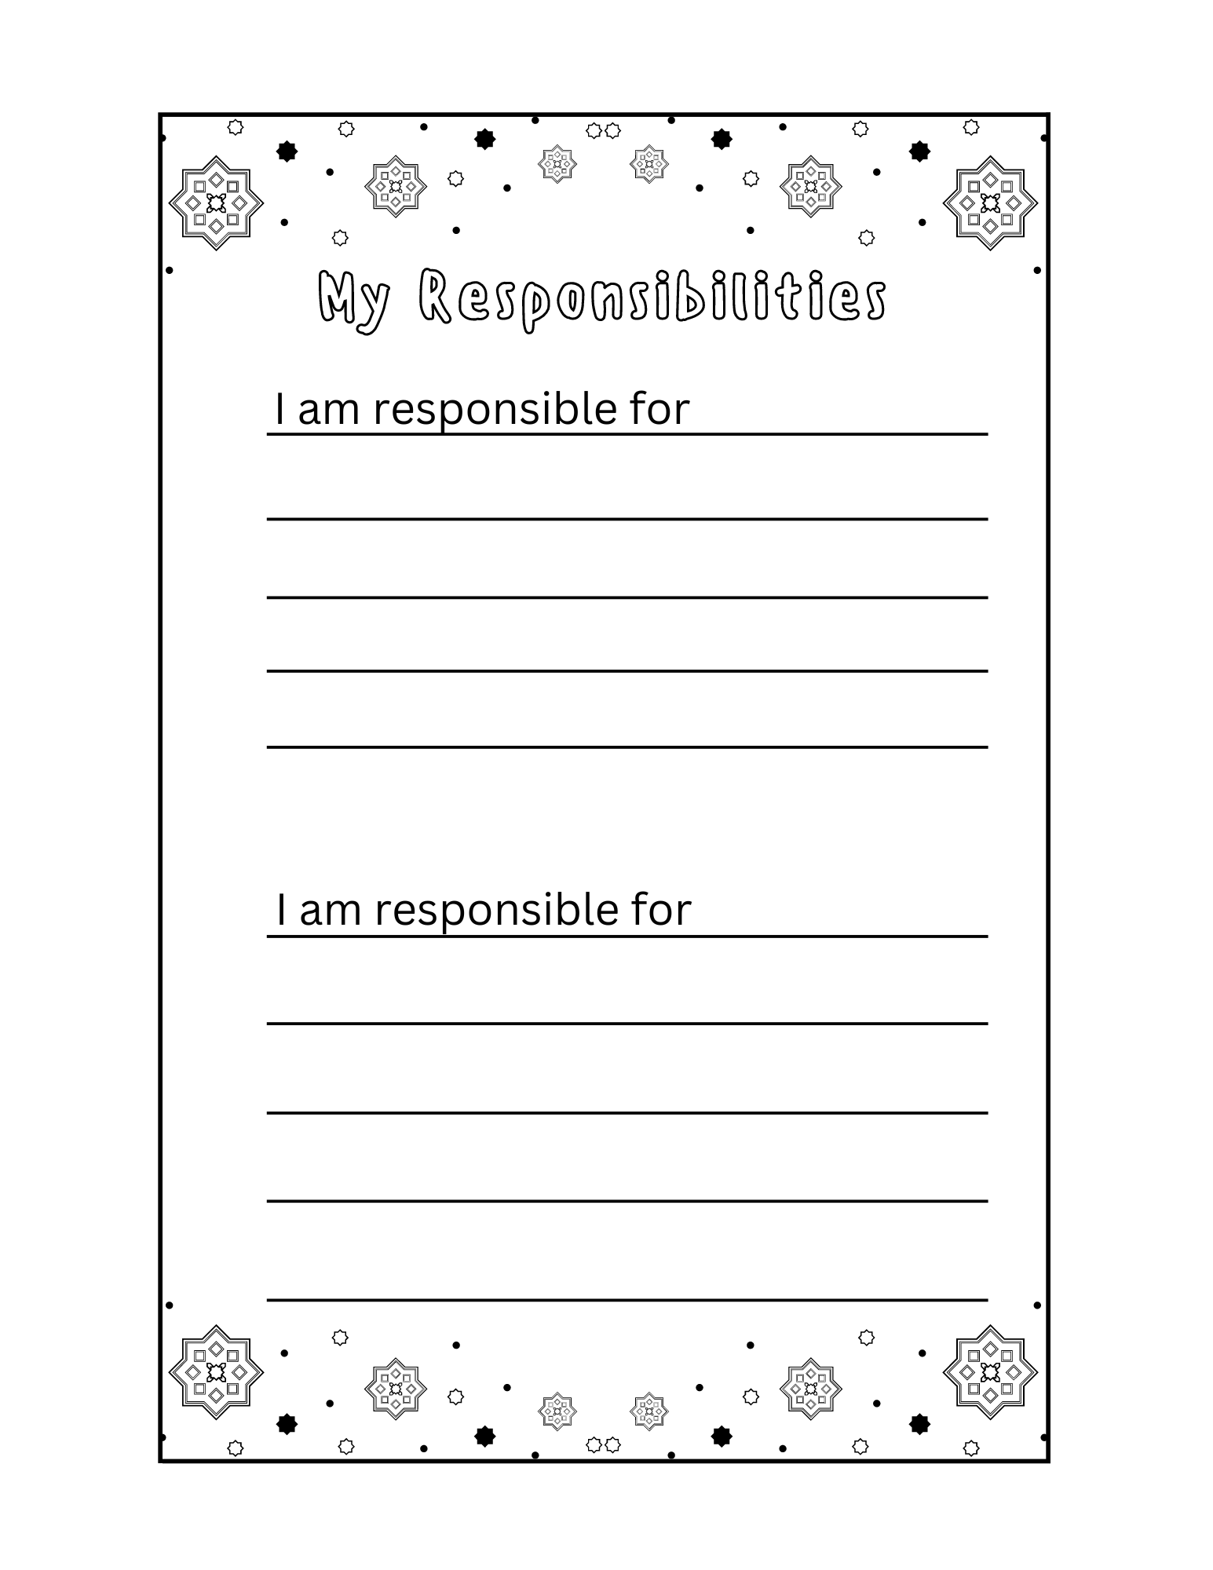
Lesson Activities:
Introduction/Hook: | -Introduce what a responsibility is (like a job you have to do, or a role)  Ms. S’s responsibility is to teach you and keep you all safe  Your responsibility at school is to be a student and learn, in the class you all have classroom jobs that are your responsibility  -When you are at home you might have different responsibilities like cleaning your room or feeding your pet
Body: | Read “Do I have to” by Nancy Loewen  Brain Break: Simon says  -Responsibility video  -On worksheet, students write down two of their own responsibilities either at home or in class (I am responsible for_____________)
Closure: | Go over school responsibilities (Ms. Therrian, Ms. Schenider, students, parents, Principal, vise principal, secretary)

Lesson 5
Name &Time (Minutes Allotted): | Social Roles, 35 minutes
Learning Standards: Curricular Competencies | Reflect on creative processes and make connections to other experiences
Learning Standards: Content | A variety of dramatic forms
Instructional Objectives | Students will be able to demonstrate their knowledge on responsibilities through drama/performance in a fun active way to show their learning
Assessment: | -Participation
Teaching Strategies: | -Encourage creativity  -Positive praise
Materials: | -Responsibilities cards/jar
Lesson Activities:
Introduction/Hook: | -Teacher gives instructions on how to play the social roles game- We will be acting out responsibilities, students will draw roles out of hat
Body: | -students take turn acting out being the teachers, parents, students, principal, vice principal in a big group space in class  -Students that are assigned teacher, will begin acting as they are “teaching” the class, some students will remain students, some will come in as parents, two will be the principle and vice principle, and all will take turns acting out their responsibilities.  -We will be able to redraw and change roles several times so that each student will be able to have a chance at a couple different roles
Closure: | Final discussion: what was it like acting out different responsibilities? How are they different from your own real-life responsibilities?

Lesson 6
Name &Time (Minutes Allotted): | Rights and Responsibilities in our classroom, 50 minutes
Learning Standards: Curricular Competencies | Use Social Studies inquiry processes and skills to ask questions; gather, interpret, and analyze ideas; and communicate findings and decisions  Communicate using sentences and most conventions of Canadian spelling, grammar, and punctuation
Learning Standards: Content | - Sentence structure  -Rights and responsibilities of individuals regionally and globally
Instructional Objectives | Students will be able to take pride in creating our own set of classroom rights and responsibilities as a class through using the previous knowledge they have gained by being assigned one of the rights to represent through written and artwork to show others in a meaningful way
Assessment: | -Participation  -Checklist for poster
Teaching Strategies: | -Speak loudly and clearly  -Focus on transition time  -Have materials ready
Materials: | -Chart paper  -Poster worksheet  -Pencil crayons/ markers  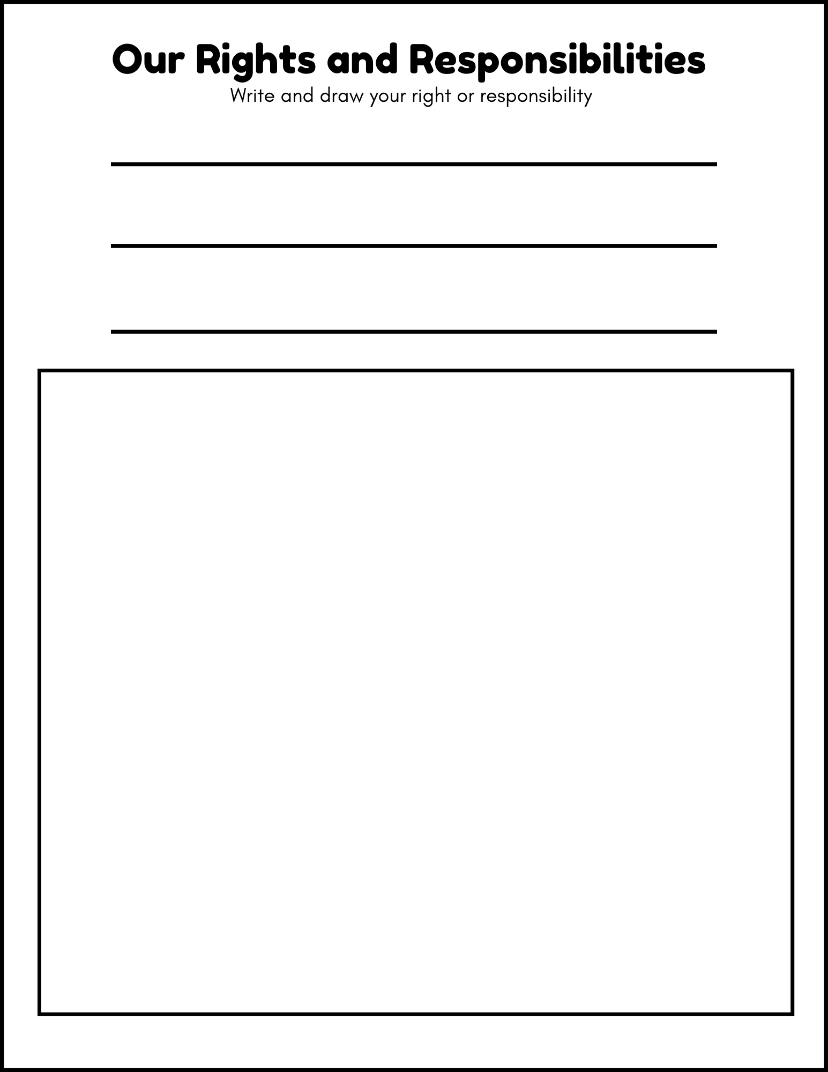
Lesson Activities:
Introduction/Hook: | -As a class sitting at the carpet, we come up with our own class rights and responsibilities based what we have learned and what we think we need in our class
Body: | -Teacher will write down our class rights and responsibilities on chart paper at the front of the class (examples: the right to learn, the responsibility to listen to others when they speak, the responsibility to take care of the classroom, the right to respect)  -Students will be assigned one of the rights/responsibilities from the poster by the teacher drawing name popsicle sticks (more than one student will most likely do the same right)  -Students will make right and responsibility posters. Each student will make a poster based on the right/responsibility they were assigned. On the worksheet they will be given, they will write out their right/ responsibility and then draw a picture of it. We will then hang these up for all to see
Closure: | -Each student will present their poster to the class (if they feel comfortable doing so)

Lesson 7
Name &Time (Minutes Allotted): | Act it out, 30 minutes
Learning Standards: Curricular Competencies | Reflect on creative processes and make connections to other experiences
Learning Standards: Content | -Rights and responsibilities of individuals regionally and globally  -A variety of dramatic forms
Instructional Objectives | Students will be able to demonstrate their knowledge on rights and responsibilities through acting them out which shows that they can decipher between rights and responsibilities
Assessment: | -Participation
Teaching Strategies: | -Give clear instructions  -Positive praise
Materials: | -Cards with rights and responsibilities on them  -List of our rights and responsibilities
Lesson Activities:
Introduction/Hook: | -Explain the game: students take turns drawing for a right or responsibility to act out and the rest of the class tries to guess which right or responsibility they are
Body: | -Play the game: Act out rights and responsibilities  -Students will act out their right or responsibility, students try to guess, a list of the rights and responsibilities that we have already gone over will be at the front of the class to refer back to, when students guess correctly a new student gets a turn
Closure: | Verbal exit ticket: what was your favourite part of the game (guessing, acting, ect)

Lesson 8
Name &Time (Minutes Allotted): | Roles in Indigenous communities, 40 minutes
Learning Standards: Curricular Competencies | Use Social Studies inquiry processes and skills to ask questions; gather, interpret, and analyze ideas; and communicate findings and decisions
Learning Standards: Content | -Rights and responsibilities of individuals regionally and globally
Instructional Objectives | Students will be able to demonstrate their knowledge on rights and responsibilities in Indigenous communities through story and participating in a sharing circler
Assessment: | -Participation  -Discussion
Teaching Strategies: | -Give clear instructions  -Positive praise  -Give everyone the chance to share  -Make sure students know that they do not have to share if they do not want to
Materials: | - Copy of the book “Lessons from mother earth” by Elaine Mcloed
Lesson Activities:
Introduction/Hook: | -Start the class by having students sit in a sharing circle on the carpet. Introduce the topic of Indigenous rights and responsibilities in their communities.  -Discuss the roles with the land and animals  -Discuss responsibilities within the community, such as caring for the people, elders, sharing stories and traditions, caring for the land and animals
Body: | -Discuss how Indigenous communities really look after the earth  -Read “Lessons from Mother Earth” by Elaine Mcleod  -Discuss how earth was looked after in the story
Closure: | -Start discussion on some responsibilities that we do to help the land and/or somethings that we might be able to do, in a sharing circle style. Each student that wants to share will get a turn, and students that do not wish to share can pass.  Teacher shares example of helping look after the animals

Lesson 9
Name &Time (Minutes Allotted): | UN rights of a child, 45 minutes
Learning Standards: Curricular Competencies | Use Social Studies inquiry processes and skills to ask questions; gather, interpret, and analyze ideas; and communicate findings and decisions  Plan and create a variety of communication forms for different purposes and audiences
Learning Standards: Content | -Rights and responsibilities of individuals regionally and globally  - Sentence structure
Instructional Objectives | Students will be able to show knowledge of what the main UN rights of a child are by making connections and keeping the information close to them to refer back to those rights in their journals
Assessment: | -Completion of righting list in journal (journals will be checked)
Teaching Strategies: | -Give clear instructions  -Have rights written down on chart paper before class  -Focus on transition time
Materials: | https://www.youtube.com/watch?v=ERKhP7bQ6Os  -chart paper  -Social journals
Lesson Activities:
Introduction/Hook: | -Introduce the UN rights of a child  -Discuss that we have already gone over three of them and that we looked at the right of education in great detail  -Play the recorded youtube video of the book “I have the right to be a child” by Alain Serres.
Body: | -Discuss the key points of the book, the main rights and what they mean  -Students pull out their social studies journals and write down the main rights of a child so that they always have them (the main rights will already be written on chart paper up at the front of the class for students to copy them down)
Closure: | -Final discussion: Students volunteer what their favourite right is and what it means to them

Lesson 10
Name &Time (Minutes Allotted): | Musical chairs rights and responsibility edition
Learning Standards: Curricular Competencies | Reflect on creative processes and make connections to other experiences  Plan and create a variety of communication forms for different purposes and audiences
Learning Standards: Content | Rights and responsibilities of individuals regionally and globally  -A variety of dramatic forms
Instructional Objectives | Students will be able to practice and showcase their learning of rights and responsibilities through a drama-based game where they quickly have to respond to what is being said
Assessment: | -Participation  -Anecdotal recording
Teaching Strategies: | -Give clear loud instructions  -Focus on classroom management
Materials: | -Chairs  -Exit ticket (just plain paper cut into small squares)
Lesson Activities:
Introduction/Hook: | -Introduce the game and set up the chairs  -Instructions: We will put our chairs in a circle and the person it will start in the middle (I will be the first person it). Everyone will sit in the chairs and the person in the middle will call out a connection to one of the rights or responsibilities that we have learned together, example; My favourite right is the right to education, my favourite need is love, I liked learning about classroom responsibilities best). Students in the chairs the connect with the statement from the person in the middle then jump up into the middle and swap chairs with someone (go to a new seat). Then the last person without a chair takes their place in the middle and makes a statement to repeat the game.
Body: | -Teacher will have example statements up on the board to help students, but they are encouraged to come up with their own. Students will get two minutes to brainstorm their own statements and talk with a partner.  -Play the game
Closure: | -Exit ticket: Students will right down their statement and hand into teacher

Lesson 11
Name &Time (Minutes Allotted): | Letter to Future Self, 50 minutes
Learning Standards: Curricular Competencies | -Plan and create a variety of communication forms for different purposes and audiences  -Use Social Studies inquiry processes and skills to ask questions; gather, interpret, and analyze ideas; and communicate findings and decisions
Learning Standards: Content | -Sentence structure  -Rights and responsibilities of individuals regionally and globally
Instructional Objectives | Students will be able to show their learning on the unit of rights and responsibilities by writing out what they have learned to their future selves on the topic and anything they found meaningful that they want themselves to remember
Assessment: | Final checklist of letter
Teaching Strategies: | -Give clear instructions  -Give helpful examples and feedback  -Focus on transitions
Materials: | -paper for letters  -Envelopes  -Letter example
Lesson Activities:
Introduction/Hook: | -Activate schema: Who knows what a personal handwritten letter is?  Who knows how to write one?  Go over what we will be doing today: Today we will be writing a letter to our future selves to tell them all about what we have learned about rights and responsibilities  -Students can write whatever they wish about what they have learned. They might write about the rights they learned, their current responsibility, a right they found interesting, a drama game we played and they really enjoyed, or a right they hope might be added by the time they graduate high school. They must write at least five sentences.
Body: | -Teacher shows example of her letter that she wrote to her future self, talking about teaching this unit to the class  -Teacher goes over what the letter must have: at least five sentences, on topic of rights and/or responsibilities, the date, the introduction of “Dear future me”, and signed name at the bottom.  -Class brainstorms what they want to write. All students must tell the teacher what they will be writing about before starting the letter. They must have a topic in mind.  -Once their topic has been cleared by the teacher, students begin writing their letter
Closure: | Once their letter is complete, students bring it to the teacher to read over  -Students can then put their letter in an envelope, seal it, write “to future me” on the front, and take the letters home to place in a safe place until they graduate high school.

Resources:
-Lesson 8 video- https://www.youtube.com/watch?v=ERKhP7bQ6Os
Lesson 4 video- https://www.youtube.com/watch?v=7ew6herS7Gg
-Canva (created my own worksheets)

Extensions to Unit:
To extend this unit into a longer and more complex unit I would look into simple and peaceful protest for change and teach the class that they can make differences when change needs to occur. It would be a great way to lead into creating our own class protest or to look into something that needs changing in the community that the students could use their voices. At this point students could send letters to the mayor or person in charge. We could also extend to look at who is in charge of making rights and have a similar class election and gamify this unit to allow the students the chance to experience some of these roles in the class.
We could also look at field trip options such as going to the local courthouse to see where things like making rights happen and learn about some of the responsibilities in this discipline.

Reflections and Revisions
I think this unit will be a fun and engaging unit for the students. At first, I wasn’t sure where to start when I looked at things like human rights and how to explain that to a grade 2/3 class. However, I decided to break it down and start with the basics. I hope that it is simple enough for the class to understand such a complex topic but engaging enough that it keeps the interested.

